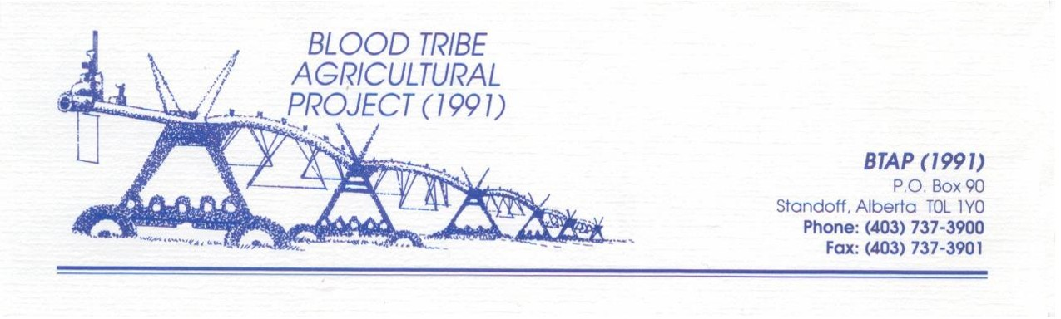

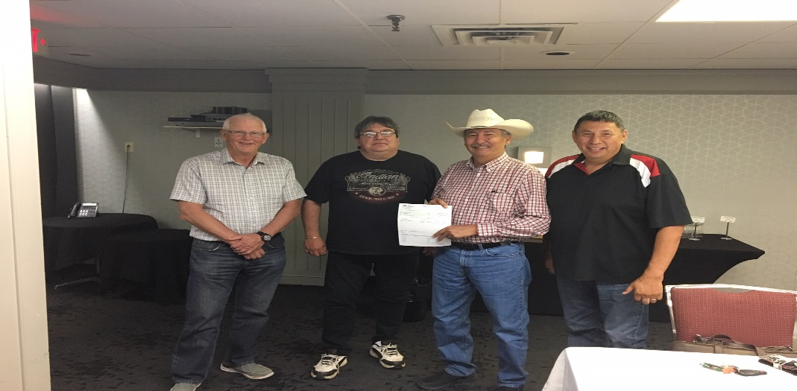

COMMUNIQUE
Blood Tribe Agricultural Project (1991)
For Immediate Release
July 12, 2019

At a Blood Tribe Agri- Business Trust Meeting on July 10, 2019, the Board of Trustees presented a dividend payment to Chief and Council in the amount of $250,000.

Council will be directing these funds to much needed community initiatives and other areas.

Please visit us at btap.ca for more information and the latest updates.

BTAP Board of Directors and Staff

